Name _______________________
Building a Parabolic Solar Cooker
Your Task
You have 4 days to research and build your solar cooker. We will test your group’s structure on the fifth day. Be sure the following bulleted list is complete by the test day.
- The solar cooker must be able to cook your food of choice (chosen as a group and approved).
- The solar cooker must cook the food in your class period.
- Your equation of the parabola used must be accurate.
- Your focal point must be accurate.

Day 1: Research
- What is a solar cooker? Look up ideas on how parabolic solar cookers are made and the materials needed to build them. Jot down your ideas below.

- How do solar cookers relate to conics? What shapes are used? Why are such shapes used? What is a focal point or focus?

- Where are solar cookers used around the world and why? Explore topics in economic advantages, health, resources.

- Who is Wolfgang Scheffler and what did he invent? How did his invention influence others? Use a source other than Wikipedia to find your information.

- Research methods to reflect maximum sunlight. Be sure to research how you will know where to move the solar cooker as the sun shifts.

Days 2, 3, 4: Calculations and Construction
You will be working with your group. Your group must plan well to make sure that you will be able to complete your structure in four class periods. To create your design follow the steps below.
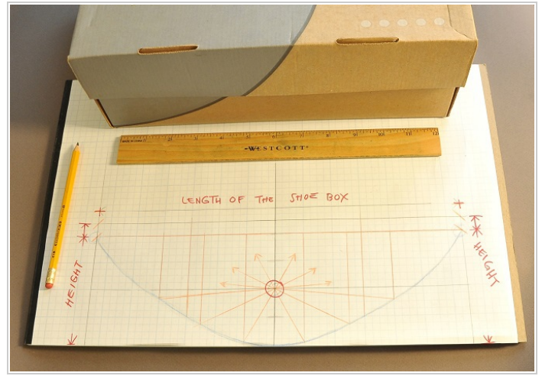
- Measure and find the lowest center of your shoe box and mark it with a dot (this is your vertex point (0,0)).

- Find two upper corners of your shoe box. Be sure they are at the same y-height. Mark the spots with a dot. Then, place graph paper over the shoebox and find the coordinate points that correspond.
write the points here: ( , ) and ( , )
- Using one point from #2 and the general equation, $y=ax^{2}$, calculate your equation the a-value and write your final equation. Show your work below.

a-value: __________________ Equation: ____________________________

- Put your equation in to your calculator to find at least 8 more points. You will need these to create a nice curve. List your points below.
- 2. 3. 4.
5. 6. 7. 8.

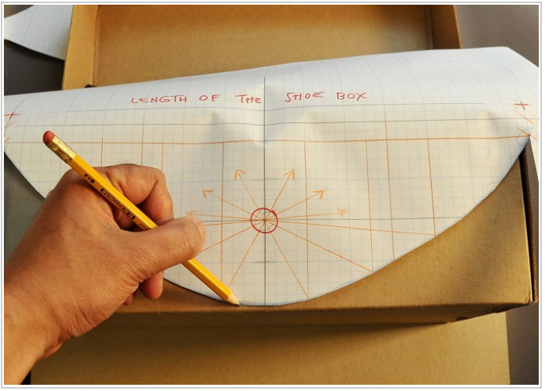
- Now that you have an accurate parabola, draw this on the graph paper provided. This will be the model you will use to cut out from the shoe box. Cut out the parabola now.

- Calculate the focal point, p, using the equation, $4p=\frac{1}{a}$. Then, plot this point on your graph paper above the vertex. This will be where your food will get the hottest.

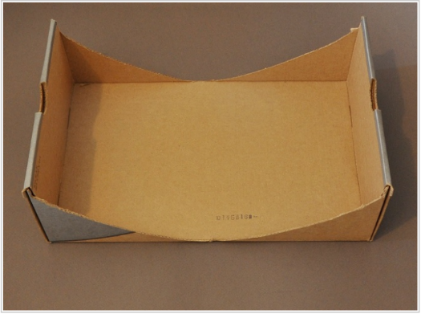
- Tape a graph paper model on each side of your shoe box. Carefully, cut out the parabola on each side.

8. Use scissors to cut out a piece of poster board that fits perfectly into the curve of the parabola in the box.
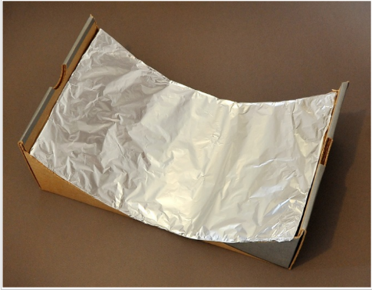
9. Glue aluminum foil to the poster board, shiny side up. Try to keep the foil as smooth as possible.

10. Carefully insert the foil-covered poster board into the shoebox and tape it in place. Be sure the shiny side of the foil faces you.
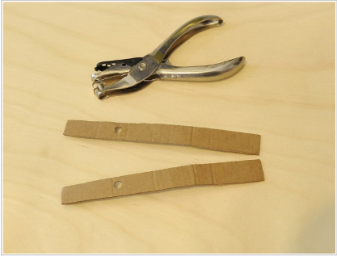
11. Use two long scraps to build supports for the skewer. They must be tall enough to reach above the focus. .

10. Use the single hole punch to make holes at the focal point, which will be at the same height as the focus is from the vertex of your parabola.
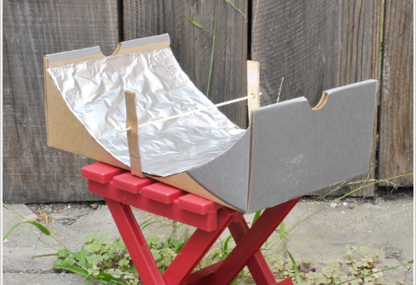

You may now add any other materials you think will help cook your food the fastest! Good luck!
Day 5: Evaluation and Testing the Cookers
Before going outside, make some predictions:
- Do you think food will cook faster if the parabola is deep or shallow? Why?

- How long do you think your food will take to cook?
Prediction: Actual:

- Make a prediction for the highest temperature your food will reach. Why do you think this? Be sure to test your temperature at 10 minute intervals and write them down below. Box the hottest temperature.
Prediction: Actual:

- Go around to another model and test their temperature at time 25 minutes. List the group members and the temperature. What do you notice?
Group:____________________________________________
Temperature: ________________
Observations and notes:

Communicating and evaluating your knowledge of the solar cookers.
Each individual will type a report as a portfolio post about our experience. This does not need to follow the guidelines of a typical post, but instead, I just want you to reflect upon what we did and what math we used. Include the following:
  - A title
  - One paragraph summarizing the experience and explain the algebra and measurements used before, during, and after building (use words such as focal point, vertex, equation of the parabola). Remember the research we did before (that is still in the turn-in bin if you need it).
  - One paragraph reflecting on things you've learned while building your cooker: What things seemed to work? What didn't work? If you could have made changes, what would they be? What food do you plan on cooking? How long do you think it will take to cook?
  - Provide photographs of your cooker.
  - Categorize this under “Math” and “Algebra II” if you have that category.
Upload this post and submit it through my website. https://sites.google.com/a/neisd.net/mrs-taplin-math/homework.

